References

Academic Literature:

Anderson, E. N. (2014). Everyone eats: Understanding food and culture, second edition.
New York University Press. https://www.jstor.org/stable/j.ctt9qfm0f

Arceo-Gomez, E. O., & Campos-Vazquez, R. M. (2014). Race and marriage in the labor market: A discrimination audit study in a developing country. The American Economic Review, 104(5), 376-380. doi:10.1257/aer.104.5.376

Bartlett, C., Marshall, M., & Marshall, A. (2012). Two-eyed seeing and other lessons learned within a co-learning journey of bringing together Indigenous and mainstream knowledges and ways of knowing. Journal of Environmental Studies and Sciences, 2, 331-340. https://doi.org/10.1007/s13412-012-0086-8

Baum, F., MacDougall, C., & Smith, D. (2006). Participatory action research. Journal of
Epidemiology and Community Health, 60(10), 854–857. https://jech.bmj.com/content/60/10/854

Berman, G., & Paradies, Y. (2010). Racism, disadvantage and multiculturalism:
Towards effective anti-racist praxis. Ethnic and Racial Studies, 33(2), 214–232.
doi:10.1080/01419870802302272

Bocskei, E. M., & Ostry, A. S. (2010). Charitable food programs in Victoria, BC. Canadian Journal of Dietetic Practice and Research, 71(1), 46-48. doi:10.3148/ 71.1.2010.46

Bodkin-Andrews, G., Lovelock, R., Paradies, Y., Denson, N., Franklin, C., & Priest, N. (2017). Not my family: Understanding the prevalence and impact of racism beyond individualistic experiences. In M. Walter, L. Karen, K. L. Martin, & G. Bodkin-Andrews (Eds.), Indigenous children growing up strong (pp. 179–208). London, UK: Palgrave Macmillan.

Booth, A. L., Leigh, A., & Varganova, E. (2012). Does ethnic discrimination vary across
minority groups? Evidence from a field experiment. Oxford Bulletin of Economics and Statistics, 74(4), 547-573. doi:10.1111/j.1468-0084.2011.00664.x

Carr, T., Sedgwick, J. R., Roberts, R., & Groot, G. (2020). The sharing circle method:
Understanding Indigenous cancer stories. SAGE publications Ltd. https://method
s-sagepub-com.ezproxy.library.ubc.ca/case/the-sharing-circle-method-understa
nding-indigenous-cancer-stories

Chin-Yee, M., & Chin-Yee, B. H. (2015). Nutrition North Canada: failure and facade
within the northern strategy. University of Toronto Medical Journal, 92(3), 13-18.
Retrieved March 28, 2021, from https://utmj.org/index.php/UTMJ/article/view/215
Coram, S. (2011). Rethinking Indigenous research approval - The perspective of a ‘stranger’. Qualitative Research Journal, 11(2), 38-47. https://doi.org/10.3316 /QRJ1102038

Davison, K. M., & Kaplan, B. J. (2011). Vitamin and mineral intakes in adults with mood
disorders: comparisons to nutrition standards and associations with
sociodemographic and clinical variables. Journal of the American College of
Nutrition, 30(6), 547-558. doi:10.1080/07315724.2011.10720001

Davison, K. M., Gondara, L., & Kaplan, B. J. (2017). Food insecurity, poor diet quality,
and suboptimal intakes of folate and iron are independently associated with
perceived mental health in Canadian adults. Nutrients, 9(3), 274. doi:10.3390/nu9030274

Davy, D. (2016). Australia’s efforts to improve food security for Aboriginal and Torres
Strait Islander peoples. Health and Human Rights, 18(2), 209-218.
https://www.ncbi.nlm.nih.gov/pmc/articles/PMC5394999/pdf/hhr-18-209.pdf

Dietitians of Canada. (2016). Addressing Household Food Insecurity in Canada -
Position Statement and Recommendations from Dietitians of Canada. Canadian
Journal of Dietetic Practice and Research, 77(3),159. doi:10.3148/cjdpr-2016019

Duarte, M. E. (2017). Network Sovereignty: Building the Internet Across Indian Country.
University of Washington. https://www.jstor.org/stable/j.ctvcwn92r

Elliot, B., Jayatilaka, D., Brown, C., Varley, L., & Corbett, K. K. (2012). We are not being
heard: Aboriginal perspectives on traditional foods access and food security.
Journal of Environmental and Public Health, 2012, 1-9. doi:10.1155/2012/ 130945

Gundersen, C., Engelhard, E., & Hake, M. (2017). The determinants of food insecurity
among food bank clients in the United States. Journal of Consumer Affairs, 51(3),
501-518. doi:10.1111/joca.12157

Holmes, E., Black, J. L., Heckelman, A., Lear, S. A., Seto, D., Fowokan, A., & Wittman,
H. (2018). Nothing is going to change three months from now: A mixed
methods characterization of food bank use in Greater Vancouver. Social Science
and Medicine, 200, 129-136. https://doi.org/10.1016/j.socscimed.2018.01.029
Holmes, E., Fowokan, A., Seto, D., Lear, S. A., & Black, J. L. (2019). Examining food
insecurity among food bank members in Greater Vancouver. Journal of Hunger & Environmental Nutrition, 14(1-2), 141-154. doi:10.1080/19320248.2018.1465001

Hu, M., Daley, A., & Warman, C. (2019). Literacy, Numeracy, Technology Skill, and
Labour Market Outcomes among Indigenous Peoples in Canada. Canadian Public Policy, 45(1), 48-73. https://www.muse.jhu.edu/article/720868.
Hughes, L., & Davidson, G. R. (2010). Effects of non-indigenous Australian human
resource managers’ gender and attitudes and applicants’ ethnicity and gender on resumé evaluations. Journal of Pacific Rim Psychology, 5(1), 1–10. doi:10.1375/prp.5.1.1

Ionescu, A. M. (2012). How does education affect labour market outcomes? Review of Applied Socio-Economic Research, 4(2), 130-144. Retrieved April 24, 2021, from https://www.researchgate.net/publication/263848494_How_does_education_affect_labour_market_outcomes

Iwama, M., Marshall, M., Marshall, A., & Bartlett, C. (2009). Two-eyed seeing and the
language of healing in community-based research. Canadian Journal of Native Education, 32(2), 3-23. Retrieved April 24, 2021, from https://www.researchgate. net/publication/309725911_Twoeyed_seeing_and_the_language_of_healing_in_community-based_research

Kerpan, S. T., Louise Humbert, M., & Henry, C. J. (2015). Determinants of diet for urban
aboriginal youth: Implications for health promotion. Health Promotion Practice,
16(3), 392-400. https://doi.org/10.1177/1524839914557862

Kinach, L., Parizeau, K., & Fraser, E. D. G. (2019). Do food donation tax credits for farmers address food loss/waste and food insecurity? A case study from Ontario. Agriculture and Human Values, 37, 383-396. https://link.springer.com/article/10.1 007%2Fs10460-019-09995-2

Lang, T., & Rayner, G. (2012). Ecological public health: The 21st century’s big idea? An
essay by Tim Lang and Geof Rayner. British Medical Journal, 345, e5466.
https://doi-org.ezproxy.library.ubc.ca/10.1136/bmj.e5466

Li, N., Dachner, N., Tarasuk, V., Zhang, R., Kurrein, M., Harris, T., Gustin, S., & Rasali,
D. (2016). Priority health equity indicators for British Columbia: Household food
insecurity indicator report. Toronto: Research to identify policy options to reduce
food insecurity (PROOF). Retrieved from http://www.bccdc.ca/pop-public-health/ Documents/Household%20food%20insecurity%20in%20BC_full%20report.pdf

Loppie Reading, C., & Wien, F. (2009). Health inequalities and the social determinants of Aboriginal Peoples’ health. National Collaborating Centre for Aboriginal Health. https://www.nccah-ccnsa.ca/docs/social%20determinates/nccah-loppie-wien_report.pdf

McCleland, A. (2011). Culturally Safe Nursing Research: Exploring the Use of an
Indigenous Research Methodology From an Indigenous Researcher’s Perspective. Journal of Transcultural Nursing, 22(4), 362-367. https://doi.org/10.1177%2F1043659611414141

McIntyre, L., Patterson, P. B., Anderson, L. C., & Mah, C. L. (2016). Household food insecurity in Canada: Problem definition and potential solutions in the public policy domain. Canadian Public Policy, 42(1), 83-93. doi:10.3138/cpp.2

Mundel, E., Bevelander, K., & Burgaretta, M. (2016). Increasing Indigenous children’s access to traditional foods in early childhood programs. Provincial Health Services Authority. http://www.bccdc.ca/pop-public-health/Documents/Increasing %20Indigenous%20children%27s%20access%20to%20traditional%20foods_full%20report.pdf

Nord, M. (2014). What have we learned from two decades of research on household
food security? Public Health Nutrition, 17(1), 2-4. doi:10.1017/S13689800130030 91

Nutrition Division. (2013). Indigenous Peoples’ food systems & well-being: Interventions and policies for healthy communities. The Food and Agriculture Organization (FAO). http://www.fao.org/3/i3144e/i3144e.pdf

OECD. (2018). “Indigenous labour market outcomes in Canada”, Indigenous
Employment and Skills Strategies in Canada, OECD Publishing, Paris,
https://doi.org/10.1787/9789264300477-6-en

Ottem, A. (2010). Healthy Eating and Food Security: Promising Strategies for BC: A
Discussion Paper. Dietitians of Canada. https://phabc.org/wp-content/uploads /2015/07/FINAL_HEFS_Report_Apr-29.pdf

Paradies, Y. (2018). Racism and Indigenous Health. Oxford Research Encyclopedia of
Global Public Health. https://doi.org/10.1093/acrefore/9780190632366.013.86

Peltier, C. (2018). An application of two-eyed seeing: Indigenous research methods with
participatory action research. International Journal of Qualitative Methods, 17(1),
1-12. https://doi.org/10.1177%2F1609406918812346

People’s Food Policy Project. (2011). Resetting the table: A people’s food policy for
Canada. People’s Food Policy Project. https://www.indigenousfoodsystems.org /sites/default/files/policy_reform/pfpp-resetting-2011-lowres_1.pdf

Place, J. (2012). The Health of Aboriginal People Residing in Urban Areas. National
Collaborating Centre for Aboriginal Health. https://www.ccnsa-nccah.ca/docs/ emerging/RPT-HealthUrbanAboriginal-Place-EN.pdf

Ramsey, R., Giskes, K., Turrell, G., & Gallegos, D. (2012). Food insecurity among adults residing in disadvantaged urban areas: Potential health and dietary consequences. Public Health Nutrition, 15(2), 227-237. doi:10.1017/S136898001 1001996

Richmond, C., Steckley, M., Neufeld, H., Kerr, R. B., Wilson, K., & Dokis, B. (2020).
First Nations food environments: Exploring the role of place, income, and social
connection. Current Developments in Nutrition, 4(8), 1. doi: 10.1093/cdn/nzaa108

Robinson, A. (2018, November 6). Chief. The Canadian Encyclopedia.
https://www.thecanadianencyclopedia.ca/en/article/chief#:~:text=Canada%20%2F%20PA%2D125840-,Definition,of%20authority%20in%20their%20communities.

Skinner, K., Pratley, E., & Burnett, K. (2016). Eating in the city: A review of the literature
on food insecurity and Indigenous people living in urban spaces. Societies, 6(2), 7. doi:10.3390/soc6020007

St-Germain, A. A. F., Galloway, T., & Tarasuk, V. (2019). Food insecurity in Nunavut
following the introduction of Nutrition North Canada. Canadian Medical Association Journal, 191(20), E552-E558. doi:10.1503/cmaj.181617

Stiegelbauer, S. M. (1996). What is an Elder? What do Elders do? First nation Elders as
teachers in culture-based urban organizations. Canadian Journal of Native Studies, 16(1), 37-66. Retrieved April 24, 2021, from http://www3.brandonu.ca/cjns/16.1/Stiegelbauer.pdf

Tachine, A. R., Bird, E. Y., & Cabrera, N. L. (2016). Sharing circles, an Indigenous
methodological approach for researching with groups of Indigenous Peoples. International Review of Qualitative Research, 9(3), 277-295. doi:10.1525/irqr.2016.9.3.277.

Tarasuk, V. & Dachner, N. (2009). The proliferation of charitable meal programs in
Toronto. Canadian Public Policy, 35(4), 433-50. doi:10.3138/cpp.35.4.433

Tarasuk, V., St-Germain, A. A. F., & Loopstra, R. (2020). The relationship between food
banks and food insecurity: insights from Canada. VOLUNTAS: International Journal of Voluntary and Nonprofit Organizations, 31(5), 841-852. doi:10.1007/s1 1266-019-00092-w

Tarasuk, V., & Mitchell, A. (2020). Household food insecurity in Canada, 2017-18.
Toronto: Research to identify policy options to reduce food insecurity (PROOF). https://proof.utoronto.ca/resources/proof-annual-reports/household-food-insecurity-in-canada-2017-2018/

Willows, N., Veugelers, P., Kim, R., & Kuhle, S. (2011). Associations between household food insecurity and health outcomes in the Aboriginal population (excluding reserves). Health Reports, 22(2), 15-20. Retrieved March 26, 2021, from https://ezproxy.library.ubc.ca/login?url=https://www-proquest-com.ezproxy.library.ubc.ca/scholarly-journals/associations-between-household-food-insecurity/docview/903972820/se-2?accountid=14656

Articles:

Bauer, P. (n.d.). Westernization. Britannica. https://www.britannica.com/topic/Westerniza tion

BC Association of Farmers’ Markets. (2020). Annual report 2020. BC Farmers’ Markets.
https://bcfarmersmarket.org/app/uploads/2021/03/BCAFM-Annual-Report-FINAL.pdf

BC Government News. (2020, June 5). Thyme for a new round of farmers market
program funding. Retrieved April 24, 2021 from, https://news.gov.bc.ca/releases /2020HLTH0031-001028

BC Ministry of Health. (2013). Evidence review: Food security. https://www2.gov.bc.ca
/assets/gov/health/about-bc-s-health-care-system/public-health/healthy-living-and
-healthy-communities/food-security-evidence-review.pdf

Biin, D., Hodgson, C., & Wilson, K. (2018, September 5). Acknowledging Traditional
Territories. Pulling Together Foundations Guide. https://opentextbc.ca/ indigenizationfoundations/chapter/acknowledging-traditional-territories/#:~:text=Unceded%20means%20that%20First%20Nations ,ancestors%20traditionally%20occupied%20and%20used.

British Columbia Teachers’ Federation. (n.d.). Timeline History of Aboriginal Peoples in
British Columbia. https://bctf.ca/uploadedFiles/Public/AboriginalEducation /AboriginalTimelineHistory.pdf

Chan, E. (2019). New BC legislation now in force to implement Declaration on the
Rights of Indigenous Peoples Act. Canada. Norton Rose Fulbright. https://www.nortonrosefulbright.com/en-ca/knowledge/publications/32ff0686/new-bc-legislation-now-in-force-to-implement-declaration-on-the-rights-of-indigenous-peoples-act.

City of Vancouver. (2021). Populations Disproportionately Impacted by COVID 19.
Current State Assessment. https://vancouver.ca/files/cov/pdi-covid-current-state-r eport-january-2021.pdf

Dachner, N., & Tarasuk, V. (2017). Food waste and food insecurity in Canada –
Diverting food waste to charitable food programs will not address food insecurity
In Canada. PROOF. https://proof.utoronto.ca/food-waste-and-food-insecurity -in-canada/
Davy, D. (2016). Australia’s efforts to improve food security for Aboriginal and Torres
Strait Islander peoples. Health and Human Rights, 18(2), 209-218.

Dictionary. (n.d.). Off-reserve. Dictionary.com. https://www.dictionary.com/browse/off-res erve#:~:text=adjective,of%20a%20designated%20Indian%20reserve.
Dietitians of Canada. (2012). Food Security Evidence Summary. PEN (Practice-based
Evidence in Nutrition): The Global Resource for Nutrition Practice.
http://www.pennutrition.com.

Feminist Research Ethics (n.d.). Decolonizing Knowledge Production. Retrieved March 18, 2021, from https://genurb.apps01.yorku.ca/courses/feminist-research-ethics/l essons/decolonizing-knowledge-production/

First Nations and Indigenous Studies. (2009). Terminology. Indigenousfoundations.arts. ubc.ca. https://indigenousfoundations.arts.ubc.ca/terminology/

First Nations Information Governance Centre. (2021, February 26). The First Nations
Principles of OCAP®. https://fnigc.ca/ocap-training/.

Fitzgerald, M., & Hill, F. (n.d.). Nutrition North Canada: Real change is yet to come.
Northern Public Affairs. http://www.northernpublicaffairs.ca/index/volume-5-issue- 1/nutrition-north-canada-real-change-is-yet-to-come/

Food Secure Canada (2018, March 23). What is Food Sovereignty. https://foodsecureca nada.org/who-we-are/what-food-sovereignty

Food Secure Canada. (2019, April 26). Why a National Food Policy in Canada matters?
https://foodsecurecanada.org/resources-news/news-media/national-food-policy-primer

Food Secure Canada. (n.d.). Discussion Paper 3 Access to Food in Urban Communities. https://foodsecurecanada.org/resources-news/newsletters/3-acces s-food-urban-communities

Government of British Columbia. (n.d.). BC farmers’ food donation corporate income
tax credit. Retrieved April 24, 2021, from https://www2.gov.bc.ca/gov/content/ taxes/income-taxes/personal/credits/farmers-food-donation

Government of Canada. (2020a). The food policy for Canada.
https://www.agr.gc.ca/eng/about-our-department/key-departmental-initiatives/food-policy/the-food-policy-for-canada/?id=1597863791042

Government of Canada. (2020b). How nutrition north Canada works. Retrieved from
https://www.nutritionnorthcanada.gc.ca/eng/1415538638170/1415538670874

Government of Canada. (2021, May 10). Implementing the United Nations Declaration
on the Rights of Indigenous Peoples in Canada. Government of Canada, Department of Justice, Electronic Communications. https://www.justice.gc.ca/eng /declaration/index.html

Grow Local Society. (2014, June 18). Traditional First Nations Food.
http://makebakegro w.com/2014/06/18/traditional-first-nationsfood/#:~:text=The% 20Coast%20Salish%20people%20relied,staples%20of%20the%20coastal%20diet.&text=The%20dried%20salmon%20was%20often,that%20is%20rich%20in%20oil.

Hanson, E. (n.d.). Reserves. Indigenous Foundations. https://indigenousfoundations.
arts.ubc.ca/reserves/

Indigenous Research Partnerships. (n.d.). Tu’wusht Garden Project – Vancouver Native
Health Society. The University of British Columbia. https://aboriginal.landfood.ubc .ca/tuwusht-garden-project-vancouver-native-health-society/

Johnson, S. (n.d.). First Nations Traditional Foods Fact Sheets. First Nations Health
Authority. https://www.fnha.ca/Documents/Traditional_Food_Fact_Sheets.pdf

Kovach, M. (2009). Indigenous methodologies: Characteristics, conversations, and
contexts. University of Toronto Press. https://ebookcentral.proquest.com/lib/ubc/d etail.action?docID=4672931

Louis, S. (n.d.). UBC Indigenous-led garden brings connection amid uncertainty. Salish
Sea Sentinel. https://salishseasentinel.ca/2020/06/ubc-indigenous-led-garden -brings-connection-amid-uncertainty/

Lupick, T. (2019, April 8). Is Vancouver’s Downtown Eastside still the “poorest postal
code” in Canada? The Georgia Straight. https://www.straight.com/news/1225081/ vancouvers-downtown-eastside-still-poorest-postal-code-canada

McElroy, J. (2019, December 4). Municipalities need more than community gardens to
fix the food gap, urban planners say. CBC. https://www.cbc.ca/news/canada/ british-columbia/metro-van-cities-food-stability-gap-2019-1.5384000

Molko, D. (2019, December 4) We have effectively turned a blind eye: Who benefits from Vancouver’s community gardens? CTV News. https://bc.ctvnews.ca/we-have-effectively-turned-a-blind-eye-who-benefits-from-vancouver-s-community-gardens-1.4716103

National Collaborating Centre for Determinants of Health. (2020).
Upstream/downstream. https://nccdh.ca/glossary/entry/upstream-downstream

Newnham, J. (2005). An Overview of Vancouver’s Downtown Eastside for UBC
Learning Exchange Trek Program Participants. UBC Learning Exchange.
https://www.learningexchange.ubc.ca/files/2010/11/overviewdtes2016.pdf

Pawson, C. (2015, November 30). Greater Vancouver Food Bank concerned over
proposed tax incentives for industrial food donations.
https://www.cbc.ca/news/canada/british-columbia/greater-vancouver-food-bank-concerned-over-tax-incentives-for-industrial-food-donations-1.3341301

PROOF. (n.d.). Household food insecurity in Canada. Retrieved April 05, 2021, from
https://proof.utoronto.ca/food-insecurity/

Province of British Columbia. (2021). B.C. First Nations & Indigenous People. WelcomeBC. https://www.welcomebc.ca/Choose-B-C/Explore-British-Columbia /B-C-First-Nations-Indigenous-People

Queen's University. (n.d.). Elders, Knowledge Keepers, and Cultural Advisors. Office of
Indigenous Initiatives. https://www.queensu.ca/indigenous/ways-knowing/elders-k nowledge-keepers-and-cultural-advisors

Simon Fraser University. (n.d.). The Potlatch Ban. The Potlatch Ban - The Bill Reid
Centre - Simon Fraser University. https://www.sfu.ca/brc/online_exhibits /masks-2-0/the-potlatch-ban.html

Statistics Canada. (2011, February 7). Archived - from urban areas to population
centres. https://www.statcan.gc.ca/eng/subjects/standard/sgc/notice/sgc-06?fbcli d=IwAR0lvD1nCAD_WtUqJQHlILYkLvrZajI6YmHFbFlxFXws3V7JbeJ8C4-IwHI

Statistics Canada. (2015, November 20). Income. https://www150.statcan.gc.ca
/n1/pub/89-645-x/2010001/income-revenu-eng.htm

Statistics Canada. (2017). Aboriginal peoples in Canada: Key results from the 2016
Census. https://www150.statcan.gc.ca/n1/daily-quotidien/171025/dq171025a-eng .htm

Statistics Canada. (2020, October 20). Impacts on Indigenous Peoples.
https://www150.statcan.gc.ca/n1/pub/11-631-x/2020004/s7-eng.htm

Truth and Reconciliation Commission of Canada. (2015). (rep.). Truth and
Reconciliation Commission of Canada: Calls to Action. Truth and Reconciliation Commission of Canada. Retrieved from http://trc.ca/assets/pdf/Calls_to_Action_ English2.pdf

Truth and Reconciliation Commission of Canada. (n.d.). Truth and Reconciliation
Commission of Canada (TRC). http://www.trc.ca/about-us.html#:~:text=The%20a greement%20sought%20to%20begin,%2460%2Dmillion%20over%20five%20years.

United Nations. (n.d.). United Nations Declaration on the Rights of Indigenous Peoples
For Indigenous Peoples. United Nations. https://www.un.org/development/desa/in digenouspeoples/declaration-on-the-rights-of-indigenous-peoples.html

University of British Columbia. (2019, August 20). What is a land acknowledgement?
Student Services. https://students.ubc.ca/ubclife/what-land-acknowledgement.

Vancouver Aboriginal Health Society. (2021). Tu’wusht. https://vahs.life/tuwusht

World Food Summit. (1996). Rome Declaration on World Food Security.
http://www.fao.org/3/w3613e/w3613e00.htm

Zgoda, K., Shelly, P., & Hitzel, S. (2016, October 17). Preventing retraumatization:
macro social work approach to trauma-informed practices & policies.
https://www.socialworker.com/feature-articles/practice/preventing-retraumatization-a-macro-social-work-approach-to-trauma-informed-practices-policies

Interviews:

Interviewee 1. UGTS Representative. Interviewed by Tatyana Daniels, Emily Chau,
Anika Cheng, Cathy Zhu, February 1st, 2021

Interviewee 2. FoodMesh Representative. Interviewed by Tatyana Daniels, Emily Chau,
Anika Cheng, Cathy Zhu, March 1st, 2021

Interviewee 3. UBC Land and Food Systems Professor. Interviewed by Emily Chau,
Anika Cheng, Cathy Zhu, April 21st, 2021

Interviewee 4. UBC Indigenous Relations Advisor. Interviewed by Emily Chau, Anika
Cheng, Cathy Zhu, April 23rd, 2021

Interviewee 5. BC Community Project Manager. Interviewed by Emily Chau, Anika
Cheng, Cathy Zhu, April 23rd, 2021

Interviewee 6. SFU Food Systems Professor. Interviewed by Emily Chau, Anika
Cheng, Cathy Zhu, May 21st, 2021

Interviewee 7. Grandview Woodland Food Connection Representative. Interviewed by
Emily Chau, Anika Cheng, Cathy Zhu, May 24th, 2021

Interviewee 8. VCC Instructor & Indigenous Chef. Interviewed by Emily Chau, Anika
Cheng, Cathy Zhu, May 24th, 2021

Appendix
Appendix 1: Glossary of Terms and Definitions

Terminology
Aboriginal refers to “the first inhabitants of Canada, and includes First Nations, Inuit, and Métis peoples” (First Nations and Indigenous Studies, 2009, section 3).

Ancestral “recognizes land that is handed down from generation to generation” (University of British Columbia, 2019).

Chiefs are the “leaders of bands, clans and/or First Nations” for many Indigenous cultures in Canada (Robinson, 2018, para. 1). They are “chosen either by group consensus or as a consequence of their ancestry, chiefs hold high positions of authority in their communities. They mainly serve as links between their people and the municipal, provincial and federal governments. Chiefs may also act as cultural and spiritual leaders” (Robinson, 2018, para. 1).

Culturally-Appropriate Foods can be identified as foods that are appropriate and meaningful for an individual or a group of people. Certain foods that are viewed as nutritious for one person or group may be viewed as inappropriate for another person or group (Anderson, 2014, pp. 225-249)

Downstream Approaches are “interventions and strategies focus[ed] on providing equitable access to care and services to mitigate the negative impacts of disadvantage on health” (National Collaborating Centre for Determinants of Health, 2020, section 1).

Elders are a sum of their experiences and are role models, advisors, recorders of history and teachers of values that are passed on from generation to generation. Elders are of great importance and highly respected for their symbolic connection to the past, their knowledge of traditional ways, teachings, stories and ceremonies (Stiegelbauer, 1996, para. 3).

First Nations is “a term used to describe Aboriginal peoples of Canada who are ethnically neither Métis nor Inuit” (First Nations and Indigenous Studies, 2009, section 4).

Food Security is when “all people, at all times, have physical and economic access to sufficient, safe, and nutritious food to meet their dietary needs and food preferences for an active and healthy life” (World Food Summit, 1996, section 2).

Food Sovereignty is defined as the right to healthy and culturally appropriate food, produced through sustainable and ecologically sound methods, and the community's right to define their food and agriculture systems (Food Secure Canada, 2018).

Household Food Insecurity is the inadequate or insecure access to food due to financial constraints (PROOF, n.d., section 1).

Marginal food insecurity is defined as to “worry about running out of food and/or limited food selection due to a lack of money for food.” (PROOF, n.d., section 1).

Moderate food insecurity is defined as to “compromise in quality and/or quantity of food due to a lack of money for food.” (PROOF, n.d., section 1).

Severe food insecurity is defined as to “miss meals, reduce food intake, and at the most extreme go day(s) without food.” (PROOF, n.d., section 1).

Indian refers to the legal identity of a First Nations person who is registered under the Indian Act and should be used only when referring to a First Nations person with status under the Indian Act and in legal contexts. This term in Canada is now considered outdated and offensive due to its colonial use in governing identity through this legislation (First Nations and Indigenous Studies, 2009).

Indian Reserve is a “tract of land set aside under the Indian Act and treaty agreements for the exclusive use of an Indian band” (Hanson, n.d., para. 1).

Indigenous is “a term used to encompass a variety of Aboriginal groups. It is most frequently used in an international, transnational, or global context” (First Nations and Indigenous Studies, 2009, section 8).

Indigenous Peoples is a monolithic term that fails to distinguish between various First Nations with their own distinct cultures. In British Columbia alone, there are over 198 diverse First Nations groups (Province of British Columbia, 2021).

Inuit refers to “specific groups of people generally living in the far north who are not considered “Indians” under Canadian law” (First Nations and Indigenous Studies, 2009, section 5).

Knowledge Keepers refers to “someone who has been taught by an Elder or a senior Knowledge Keeper within their community. This person holds traditional knowledge and teachings, they have been taught how to care for these teachings” (Queen’s University, n.d.).

Labour Market Outcomes “are assessed mainly using different employment/unemployment rates as well as elements of wages and earnings. The findings show that the higher one's level of education, the better one's chances of getting a job and keeping the status of employed person in times of crisis on the labour market.” (Ionescu, 2012, p.133).

Metis refers to “a collective of cultures and ethnic identities that resulted from unions between Aboriginal and European people in what is now Canada” (First Nations and Indigenous Studies, 2009, section 6).

Native is a “general term that refers to a person or thing that has originated from a particular place. The term “native” does not denote a specific Aboriginal ethnicity (such as First Nation, Métis, or Inuit)” (First Nations and Indigenous Studies, 2009, section 9).

Off-reserve refers to Indigenous Peoples “located on or living in a place that is not part of a designated Indian reserve” (Dictionary, n.d., section 1). This can include urban areas, remote and rural communities.

On-reserve refers to Indigenous Peoples living on a designated Indian reserve

Participatory Action Research (PAR) is an approach to research that is “based on reflection, data collection, and action that aims to improve health and reduce health inequities through involving the people who, in turn, take actions to improve their own health.” (Baum et al., 2006, p. 854)

Peoples is a term that “recognizes that more than one distinct group comprises the Aboriginal population of Canada” (First Nations and Indigenous Studies, 2009).

Racism is the “unfair and unavoidable disparities in power, resources, capacities, or opportunities centered on ethnic, racial, religious, or cultural differences” (Paradies, 2018, p.1)

Sharing Circles are an Indigenous research methodology which includes open-structured, conversational style methodology that respects storytelling within a cultural protocol context (Kovach, 2009). They allow for a holistic, in-depth view of personal experiences and provide a culturally relevant and culturally sensitive approach (Tachine et al., 2016). The circle symbolizes continuity and equity and is a safe, inclusive and non-judgemental space to share beliefs, perceptions and experiences (Carr et al., 2020).

Systemic Racism (also known as “institutional” or “organizational” racism) encompasses a range of processes, practices and policies (Berman & Paradies, 2010). This often includes efforts to assimilate Indigenous Peoples into mainstream culture, but fail due to racist eclusion, preventing them from “enjoying the full benefits of the dominant culture” (Paradies, 2018, p. 3).

The First Nations Principles of OCAP establishes how data and information collected from First Nations is protected, used or shared by the four principles (OCAP) (First Nations Information Governance Centre, 2021)

Ownership affirms that First Nations have ownership over their knowledge, data and information shared in research

Control affirms the rights of First Nations communities and representative bodies to seek control over all aspects of research and information management from start to finish. This extends to the control of: resources, review, and planning processes.

Access is the principle that First Nations must have access to information and data about themselves and their communities, rights to manage and decide their access to their collective information, no matter where it is held.

Possession is the concrete principle that First Nations have physical control over their data

Traditional territory is a “geographical area identified by a First Nation as the land they and/or their ancestors traditionally occupied and used” (Biin et al., 2018).

Traditional Foods in coastal Indigenous communities include traditionally harvested and processed food such as: salmon, game meats, shellfish, etc. (Grow Local Society, 2014).

Two-Eyed Seeing Approach is “to see from one eye with the strengths of Indigenous ways of knowing, and to see from the other eye with the strengths of Western ways of knowing, and to use both of these eyes together” (Bartlett et al., 2012, p. 335).

Unceded means that “First Nations people never ceded or legally signed away their lands to the Crown or to Canada” (Biin et al., 2018). 95% of British Columbia is on unceded, traditional First Nations Territory (Biin et al., 2018).

Upstream Approaches are “interventions and strategies that focus on improving fundamental social and economic structures in order to decrease barriers and improve supports that allow people to achieve their full health potential” (National Collaborating Centre for Determinants of Health, 2020, section 1).

Urban Area is defined as “a concentration of population at a high density. It is the opposite of rural, where the population is not concentrated but dispersed at a low density” (Statistics Canada, 2011, para. 1). It can be further divided into small population centres, medium population centres and large urban population centres, depending on the population size in areas that are considered urban (Statistics Canada, 2011). In our project we primarily focused on medium or large urban population centres, areas where Indigenous populations can gather and come from many different cultures and geographical locations (off-reserve, on-reserve, small rural, large rural, northern, etc.).

Western(ization) is the adoption of European culture and norms (Bauer, n.d.).

Appendix 2
Historical Context
In 1778, Britain claimed the coast of BC, and by 1849 Vancouver Island was formally established as a British colony (British Columbia Teachers’ Federation (BCTF), n.d.). James Douglas purchased 14 lands from Indigenous Peoples, known as the “Douglas Treaties”, covering approximately 576 km² (BCTF, n.d.). Douglas made payments in blankets and promised rights to fisheries and hunting on unsettled lands “as formerly” (BCTF, n.d.). “Unsettled lands” and “fisheries as formerly” was not defined (Harris, 2012, p. 106) 一 this ambiguity led to a lack of available areas to access foods, which likely increased risk for food insecurity. A policy was set, allowing a maximum of 10 acres of reserve land per Indigenous family, while settlers are allowed 320 acres (BCTF, n.d.). This lack of land access restricted the availability of foods that could be gathered for Indigenous Peoples.

The year 1858 is when the mainland of British Columbia (BC) was colonized (BCTF, n.d.). As this is later than many other provinces such as Quebec (1604), Indigenous Peoples in BC may have stronger ties to their culture compared to other provinces (Interviewee 7, Indigenous UBC Student). Thus, Indigenous Peoples living in BC may have stronger ties to knowledge and skills of preparation and processing of traditional foods, which can help increase food security, if given access to these foods.

The British North American Act created the country now known as Canada in 1867, which gave the jurisdiction of lands and resources to the provinces (BCTF, n.d.). The federal government is now “responsible” for Indigenous Peoples (BCTF, n.d.). The Canadian parliament passes the “Act of Gradual Civilization of Indian Peoples”, and the Indian Act becomes a key tool for assimilation (BCTF, n.d.):
- Creation of reserve lands that are not reflective of the traditional territories of Indigenous Peoples
- Creation of puppet “band councils” that replace the authority of traditional governments
- Defining who is “Indian” under the Indian Act

Assimilation of Indigenous Peoples cultures endangered the connection to knowledge of cultural practices and skills needed to prepare and process traditional foods, threatening food security. In 1874, the Indian Act officially became law (BCTF, n.d.).

In 1878, the Canadian government prohibited the use of nets in freshwater, and distinguished a difference between “food” and “commercial fishing”, interfering with Indigenous fishing rights and ultimately, their access to traditional foods (BCTF, n.d.). An amendment was made to the Indian Act in 1884, prohibiting potlatch and sundance (BCTF, n.d.). Potlatches are traditional, gift-giving feasts and were the primary economic system of Coastal First People (Simon Fraser University, n.d., para. 3). A significant aspect of the potlatch was to pass on a family’s rights, privileges and inheritances, including rights to land, fishing holes, berry patches, and hunting grounds (Simon Fraser University, n.d., para. 3). A law for this amendment was enforced on a large scale from 1890-1920s, and the law was revoked in 1951 (BCTF, n.d.).

The Federal Fisheries Act was introduced in 1889, prohibiting Indigenous Peoples from selling or owning fishing licences (BCTF, n.d.). Indigenous Peoples working for fish companies are paid 5 cents per fish, while White settlers are paid 10 cents per fish (BCTF, n.d.). This restriction on fish as well as limited income further exacerbated access to foods and food security for Indigenous Peoples.

The residential school system was introduced in 1893, making it clear that the intention was to destroy Indigenous language and culture (BCTF, n.d.). Residential schools substantially weakened cultural ties to traditional ways of knowing, learning and overall knowledge of the Indigenous community.

In 1947, status “Indians” in BC received the right to vote (BCTF, n.d.). The Indian Act was amended in 1950, and prohibition of potlatch, sundance and land claim activities were lifted (BCTF, n.d.). Indigenous Peoples received the right to vote in federal elections in 1960, and residential schools began closing down, with the last residential school closing in 1996 (BCTF, n.d.). Prime Minister Stephen Harper officially apologizes to former students of residential schools on behalf of the Canadian government on June 11, 2008 (BCTF, n.d.). In 2009, Primer Minister Stephen Harper claimed that Canada has “no history of colonialism” at the G20 Summit press conference in Pittsburgh, USA (BCTF, n.d.).

The Truth and Reconciliation Commission (TRC) of Canada was part of the Indian Residential Schools Settlement Agreement (Truth and Reconciliation Commission of Canada, n.d., “The Indian Residential Schools Settlement Agreement” section). As part of its mandate, the TRC published “94 Calls to Action” in 2015 as an attempt to mend the trauma caused by residential schools between Indigenous Peoples and settlers, and to approach reconciliation. The “94 Calls to Action” calls for action in different areas, including but not limited to: Canada’s approach to education, health care, justice, and commemoration to include and amplify Indigenous voices and increase Indigenous figures in these areas (Truth and Reconciliation Commission of Canada, 2015).
The United Nations Declaration on the Rights of Indigenous Peoples (UNDRIP) acts as a universal framework to establish the minimum principles for the “survival, dignity and wellbeing” of Indigenous Peoples and was adopted by the United Nations on September 13, 2007 (United Nations, n.d.). UNDRIP was adopted by 144 countries, with 11 abstentions and 4 countries voting against it 一 one of which including Canada (United Nations, n.d., “Historical Overview” section). Canada fully adopted UNDRIP in 2016 (Government of Canada, 2021). Along with the delay in adoption, action was taken only recently in 2019, with BC leading the implementation into legislation (Chan, 2019).
Geographical Location
British Columbia has the second-highest Indigenous population in all of Canada at about ~270,585 (Statistics Canada, 2017). In addition, BC is home to over 198 distinct First Nations, each with their own unique traditions and history. Moving into the urban context of Vancouver, which is on the traditional, ancestral and unceded territory of the Musqueam, Squamish, and Tsleil-Waututh nations, there are about ~61,455 urban Indigenous Peoples in Vancouver with the majority being First Nations (Statistics Canada, 2017).

BC is located on the west coast. Living on the coastal region affects the traditional diet of Indigenous Peoples living in BC. Traditional and cultural foods are foods that have been traditionally harvested, processed and prepared, and often consist of salmon, eulachon, herring, shellfish, moose, deer, grouse, seaweed, roots, berries and more (Johnson, n.d.). Due to the impact of colonization and regulations on hunting, gathering and fishing, many Indigenous Peoples have decreased access to traditional foods due to inaccessibility of traditional ingredients and lack of knowledge and skills on how to prepare traditional foods due to weakened cultural ties.

Regarding where urban Indigenous Peoples reside in Vancouver, the Downtown Eastside neighbourhood is home to Canada’s largest urban population of First Nations peoples which is known for having “one of the poorest'' postal codes in all of Canada (Lupick, 2019). The Downtown Eastside struggles with various complex challenges including poverty, mental illness, susbtance use and addiction, drug dealing, prostitution, crime, inadequate and insecure housing, prevalence of disease such as HIV/AIDS, hepatitus, tuberculosis and lack of meaningful employment (Newnham, 2005). Many complex social issues prevalent in the Downtown Eastside and the disproportionate number of Indigenous Peoples residing in this neighbourhood can be linked to intergenerational trauma, colonization and the cultural assimilation and abuse experienced in residential schools. When addressing food insecurity in the urban Indigenous population in Vancouver, we need to look at the intersecting factors that contribute to food insecurity and the complex challenges surrounding urban Indigenous Peoples in Vancouver and BC.
Current Context and COVID-19 Pandemic
The COVID-19 pandemic has brought the issues of systemic racism and social inequalities to the forefront for Indigenous Peoples. More specifically, urban Indigenous Peoples are being overlooked during vaccinations even when the majority live in the Downtown Eastside which had one of the highest rates of COVID cases per capita in January 2021 (City of Vancouver, 2021). In addition to these high rates of COVID, many experienced loss of employment which resulted in loss of income and an increase in food insecurity. COVID-19 has furthered the gap between socioeconomic disparities as more people were unable to meet basic needs including food and even those who were able to meet basic needs experienced loss of income and financial stress (City of Vancouver, 2021). Even prior to COVID-19, 20% of Vancouver’s population lived below the national poverty line meaning that family disposable income was not sufficient to meet basic needs (City of Vancouver, 2021). In May 2020, 34% of BCCDC survey respondents in Vancouver reported difficulty meeting financial needs and 13% reported increased food insecurity (City of Vancouver, 2021). In addition, racialized groups and people in the Downtown Eastside were the most likely to be concerned about food security (City of Vancouver, 2021). This is unsurprising as food insecurity is correlated with loss of employment and income.

Appendix 3

Research Methods
Our team developed a relationship with an individual from the Gitxsan and Wet'suwet'en First Nations. We consulted with them throughout our project and valued their lived experience with food insecurity which informed our research. In addition, we collaborated with UGTS, a Vancouver-based, Indigenous-led non-profit organization focused on empowering Black, Indigenous, People of Colour (BIPOC) communities. We partnered with UGTS to evaluate their Essential Food Basket program which aims to provide fresh food weekly to BIPOC families in the Lower Mainland. Additionally, we conducted a literature review and interviewed eight individuals from UBC, UGTS, SFU, FoodMesh, Grandview Woodland Food Connection and Vancouver Community College. To avoid perpetuating harm on communities, we chose not to interview other Indigenous Peoples that we did not have an existing relationship with.

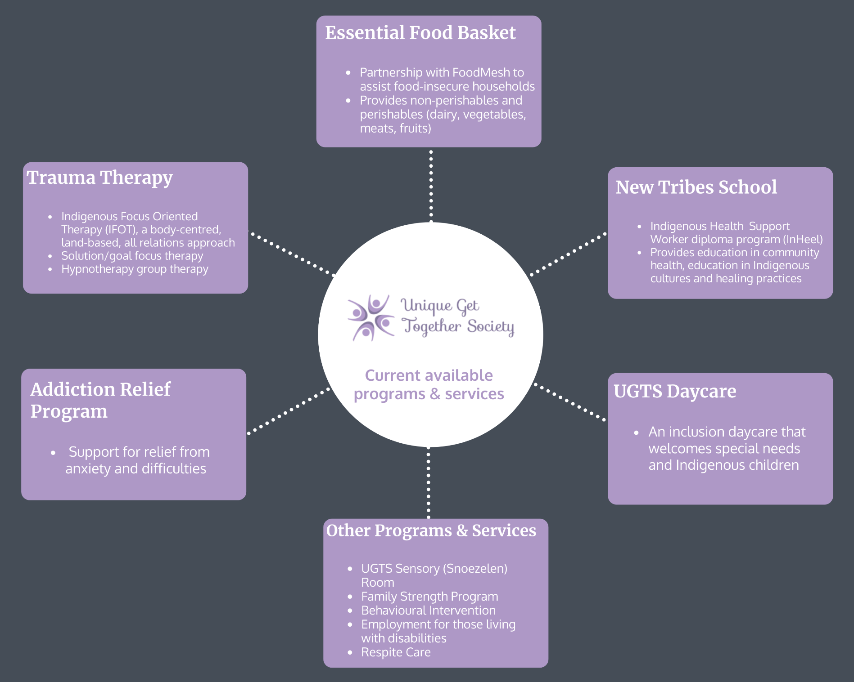

Appendix 4
Indigenous Determinants of Health
The social determinants of Indigenous health involve interrelated and intersecting determinants that affect the physical, emotional, mental and spiritual aspects of health for Indigenous Peoples, with consideration of the socio-political context and its effect on this population (Loppie Reading & Wien, 2009). They are categorized as proximal, intermediate and distal determinants of health, which can all influence each other in dynamic and complex ways (Loppie Reading & Wien, 2009). The proximal determinants of health consist of conditions that can directly impact not only physical health but also emotional, mental, and spiritual health, and can be viewed as representing the “root” of health outcomes (Loppie Reading & Wien, 2009, p. 15). They include health behaviours, the physical and social environment, socioeconomic status (employment, income, and education) and food insecurity (Loppie Reading & Wien, 2009). The intermediate determinants of health can be viewed as the “origin” of many proximal determinants (Loppie Reading & Wien, 2009, p. 15), and include healthcare systems, educational systems, community infrastructure, resources and capacities, environmental stewardship and cultural continuity (Loppe Reading & Wien, 2009). Cultural continuity can be viewed as the “degree of social and cultural cohesion within a community” and includes sharing and passing traditions and traditional knowledge within families or from Elders to following generations (Loppie Reading & Wien, 2009, p.18). The distal determinants of health have substantial influence on constructing the intermediate and proximal determinants of health, with regards to the historic, political, social and economic context (Loppie Reading & Wien, 2009). These include colonialism, racism and social exclusion, and self-determination (Loppie Reading & Wien, 2009).

Appendix 5
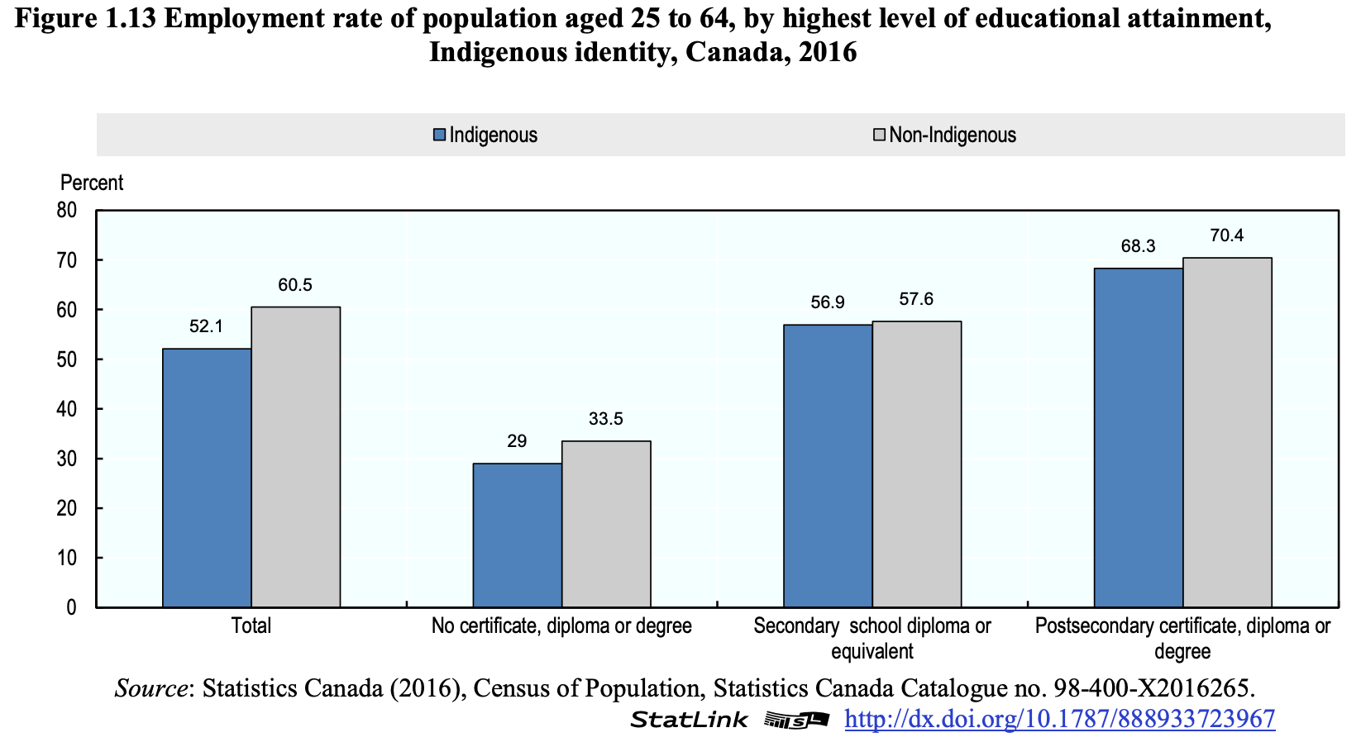

Appendix 6
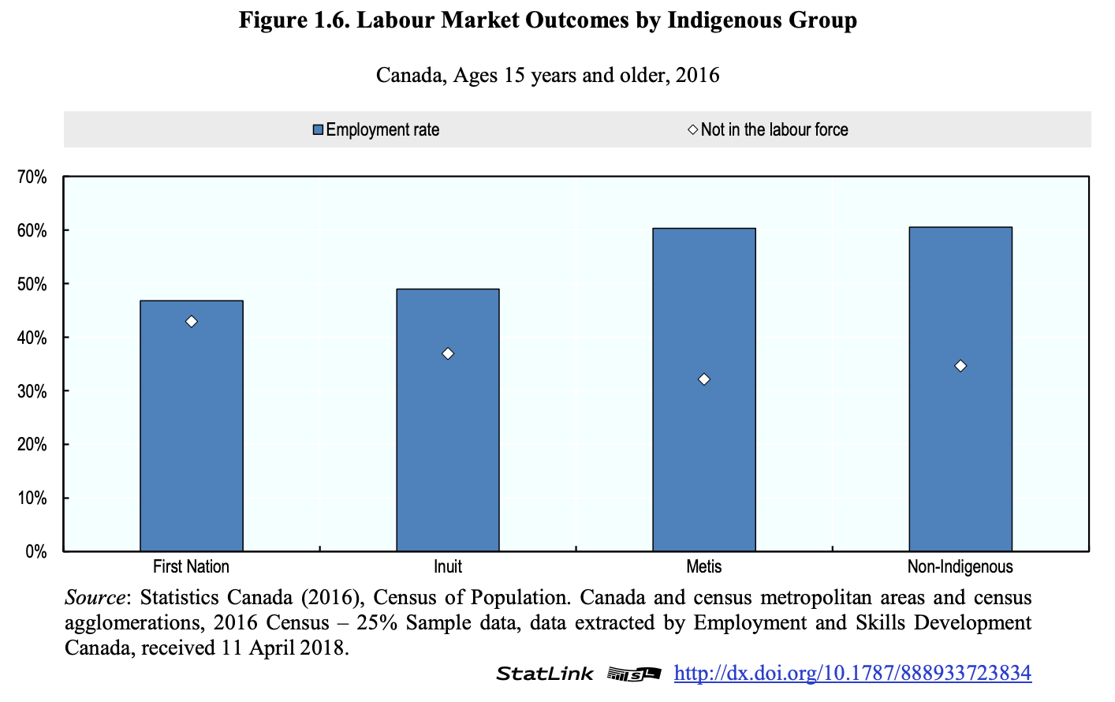

Appendix 7
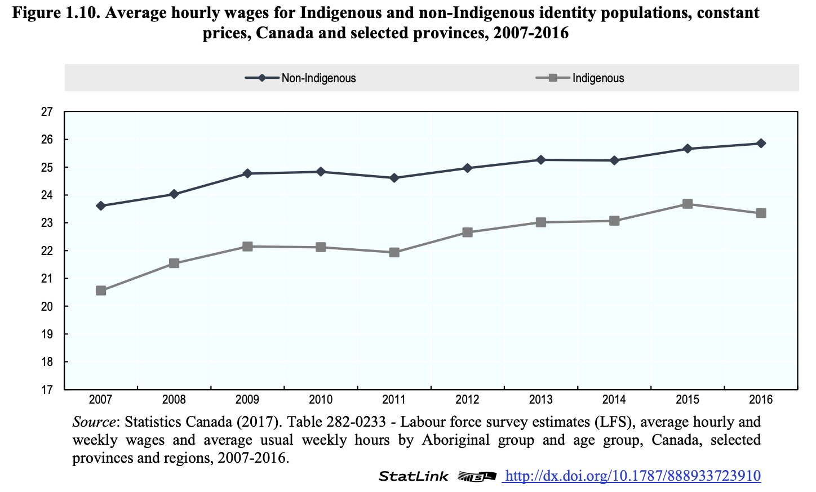

Appendix 8
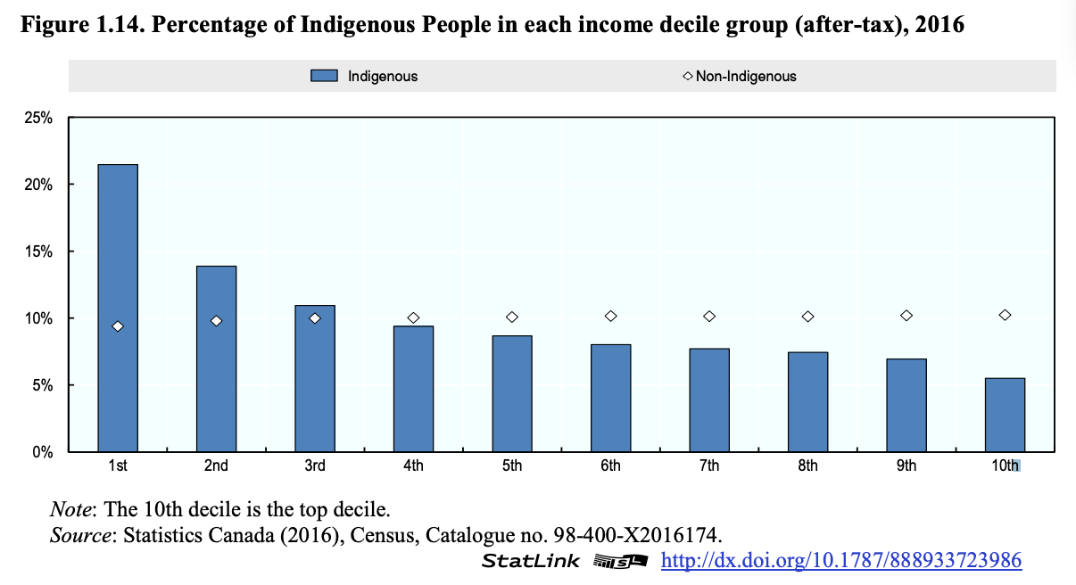

Appendix 9: UGTS Survey
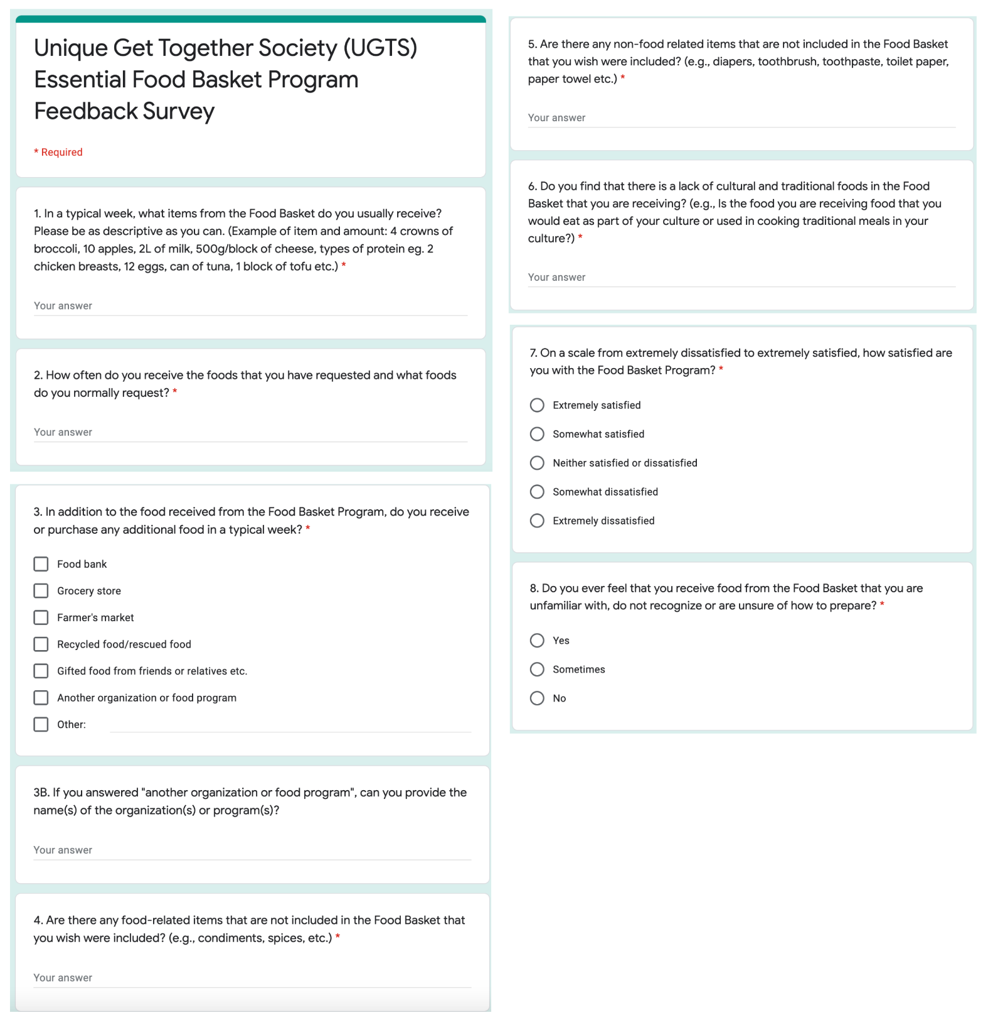

Appendix 10: Monolithic Terms
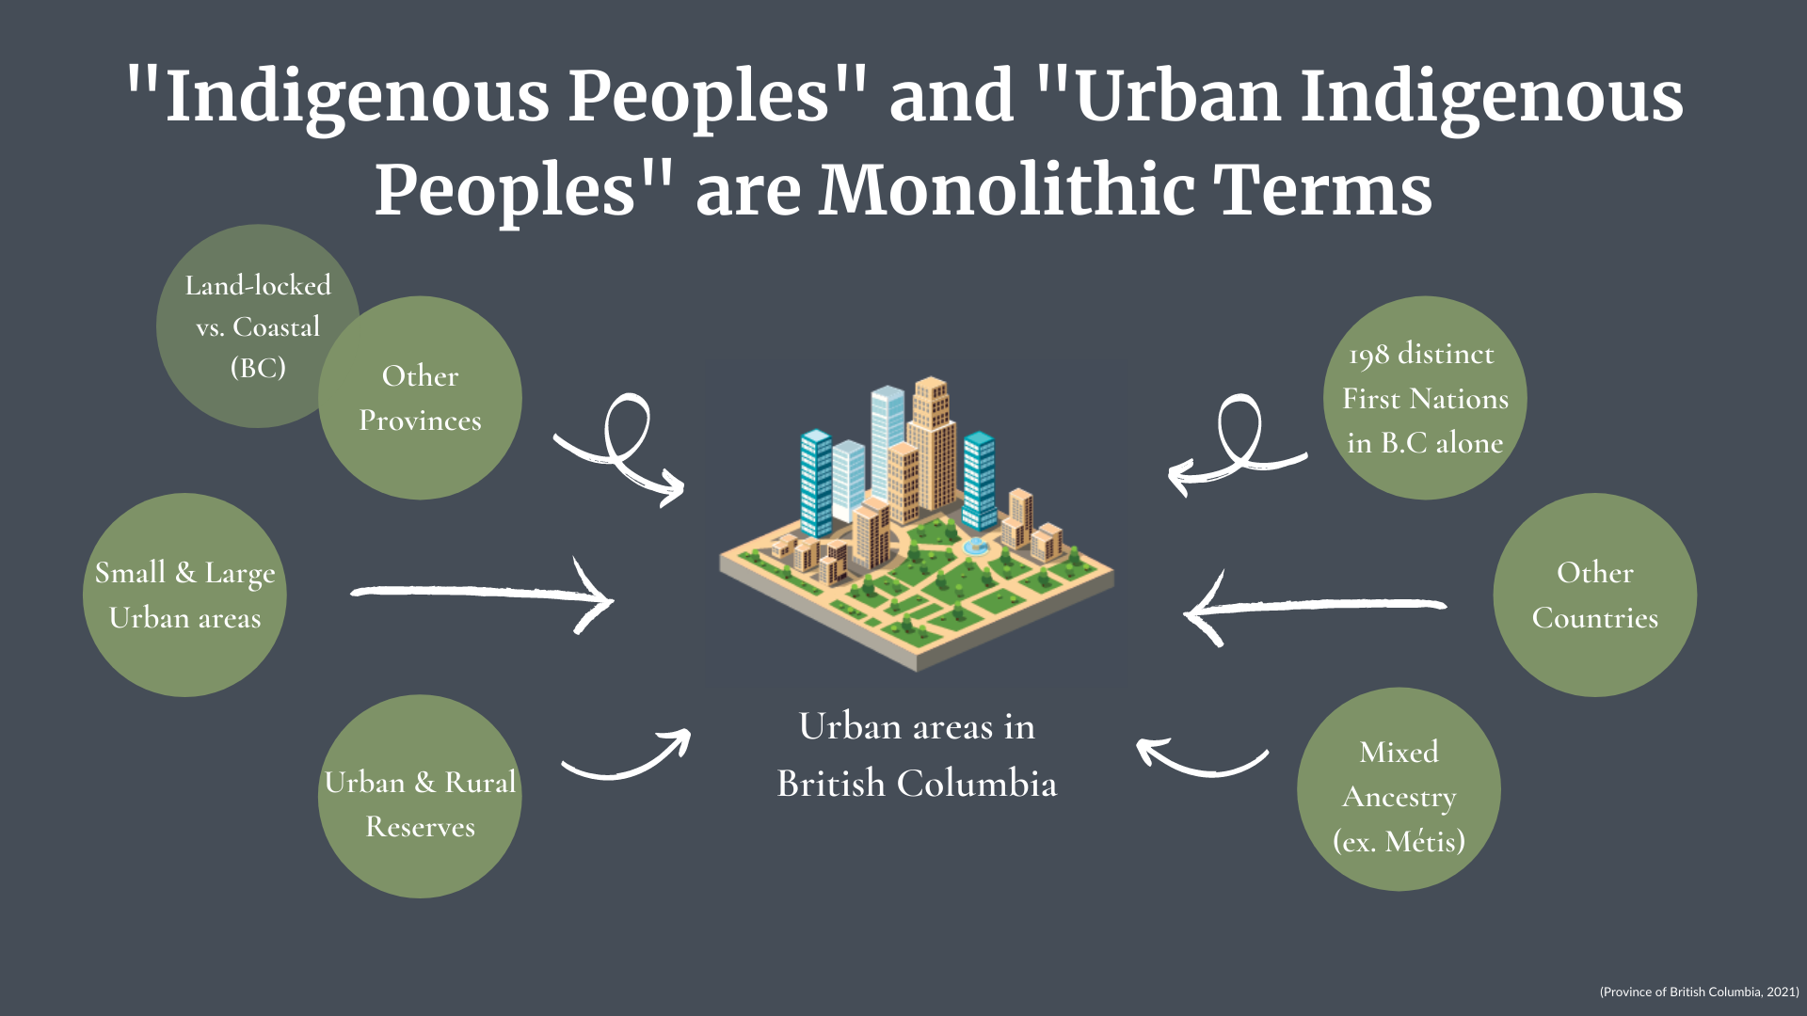

Appendix 11: TCPS 2: CORE
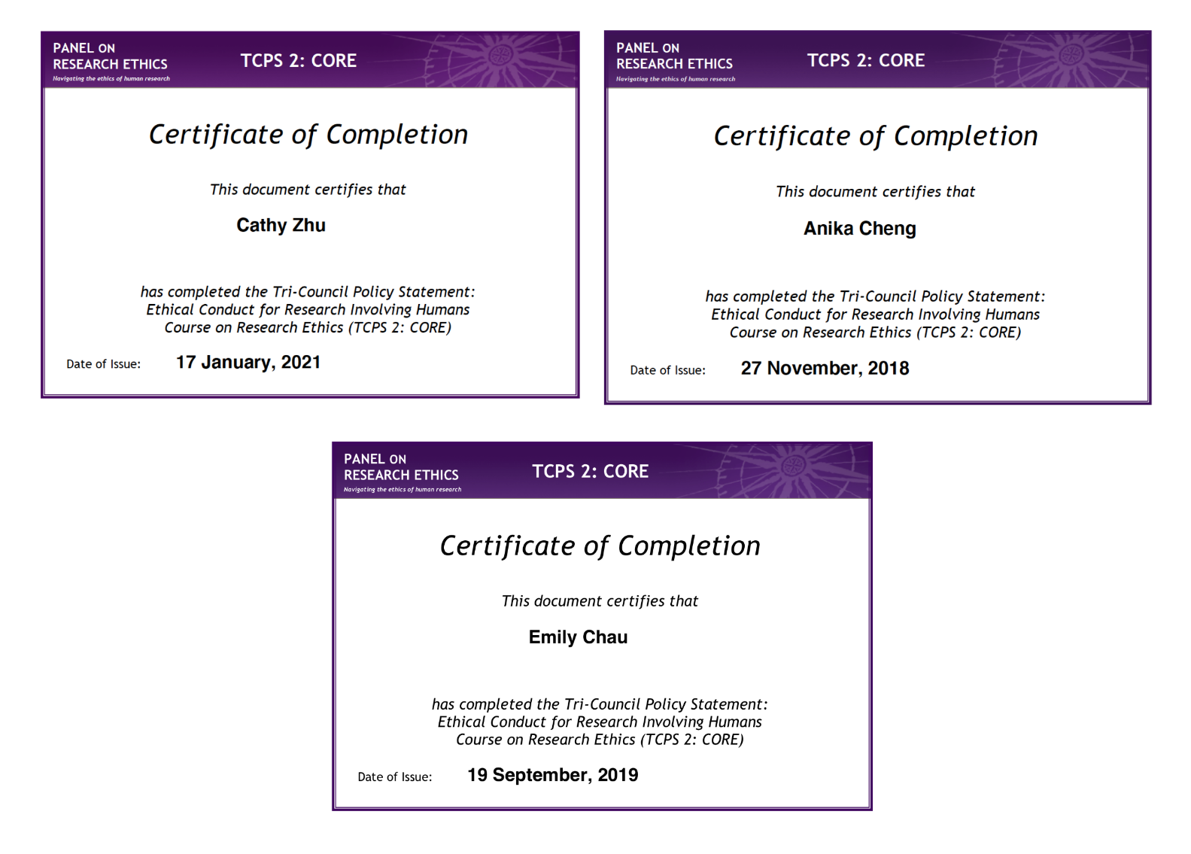

Appendix 12: Dietitians of Canada Population and Public Health Needs Assessments 2019

